West Virginia

Department of Health and Human Resources

Center for Threat Preparedness

Hospital Preparedness Program (HPP)

Inventory Management Protocol

May 2021

This document serves as the West Virginia Department of Health and Human Resources (DHHR), Center for Threat Preparedness (CTP), Hospital Preparedness Program (HPP) Inventory Management Protocol and has been developed by staff of the CTP. It shall be maintained for use in managing medical countermeasures inventory and distribution of regional and state supplies, including select pharmaceutical and non-pharmaceutical medical supplies, and Personal Protective Equipment (PPE).

The CTP and the Healthcare Education Foundation (HEF) of West Virginia purchase pharmaceuticals, other medical materiel, or supplies (e.g., PPE) with U.S. Department of Health and Human Services (HHS), Assistant Secretary for Preparedness and Response (ASPR) HPP funds on behalf of the healthcare system when necessary and in preparation for a large scale emergency, such as the COVID-19 pandemic, that would exceed individual facilities’ supply capacity and ability to respond.

The CTP and the HEF maintain
- Strategies for acquisition, storage, and rotation of supplies
- Inventory Management Program Protocols for all cached material
- Policies relating to the activation and deployment of their stockpile
- Shelf-life extension program details for all material eligible and deployment of material nearing expiration
- Strategies for aligning contracts, as appropriate
When possible, the CTP and HEF use a regional approach to PPE procurement, storage, and distribution as is encouraged by the ASPR. This procurement approach offers significant advantages in pricing and consistency for staff, especially when PPE is shared across health care organizations in an emergency. Additionally, in circumstances where HCC members are part of a larger corporate health system, a balance between corporate procurement and regional procurement is considered.
When emergency procurement of supplies and equipment is necessary requiring a state response, each agency has procurement procedures and some (DHHR included) have emergency purchase cards (P Cards) for use. Emergency purchase rules can be put in effect that will waive some of the normal procedures and remove barriers that could cause delays. If the state has declared an emergency (governor’s proclamation), the procurement capability of the Department of Homeland Security and West Virginia Emergency Management Division can then also be accessed, which can include, among other things, the acquisition of property. Other related resources can be requested through local or state emergency management, including the use of EMAC (Emergency Management Assistance Compact).

Identifying and Sharing Health Care Resources Statewide Strategy
The Emergency Preparedness Resource Inventory (EPRI), developed by the Healthcare Education Foundation (HEF) of West Virginia and hosted on the West Virginia Hospital Association (WVHA) data portal, is a database of “available and shareable” health care resources at individual facilities and from other response partners in the Coalition. The current version of this database is accessible on the WVHA.org website (under “HEF”, “Emergency Preparedness”, “HPP Coalition Systems”). Information listed in EPRI is entered voluntarily by Coalition members to document resources that may be available to share if not being used by the host agency/facility. These resources may be used to support medical facilities, shelter operations, field treatment sites, alternate care sites, and medical providers and facilities that assist in caring for their communities during a disaster. The typical process for sharing assets is per the county’s emergency management request process or via direct communication between the requesting facility and the organization owning/storing the asset.

WV Health Care Coalition (HCC) Regional Coordinators encourage members to update their resource inventory information annually to confirm the type, name, and quantity of health care response supplies and equipment. Individual facilities are responsible for maintaining their resources in a state of readiness and should utilize durable equipment for exercises and trainings, where appropriate. Since these resources may contain materials that have expiration dates and require rotation, each facility or agency should use an organizationally appropriate process to manage their inventories and keep inventories up to date whenever fiscally and logistically feasible.
During times of medical surge, some resources (listed or not in the EPRI) may be deemed to be at a critical or scarce level, as determined by individual facilities, health care systems, Coalitions, or the State Health Command. An effective response to increased hospitalizations and/or patient care needs is dependent on input and frequent updates about the status of resources (medications, supplies, equipment, trained staff, etc.). For example, an infectious agent with respiratory implications (like COVID-19) requires frequent updates to information on the number, locations, and usability of Personal Protective Equipment (PPE) and ventilators. Resource status is the responsibility of individual facilities, with reporting to the Coalition, county health department, county emergency services, and/or State Health Command in some situations.
When a health care facility recognizes that resources are at a critical or scarce level, the process is to exhaust supplies from: 1) internal and local caches, 2) acquired from other Coalition partners, and 3) through local partners/vendors. Discussions about resource and supply inventories routinely occurs within each facility/agency, between health care facilities, and through communications (emails, electronic communications platforms, and conference calls) among health care system partners, CTP, and other DHHR representatives. Hospitals share available resources on a regular basis and this process also applies during medical surge, as operationally feasible based on caseload and other factors. If operational needs are still not met, the next step is for the facility to request Regional, State, or Federal supplies through its county Office of Emergency Services and/or the WV State Health Command. Resources acquired from State or Federal sources may be distributed at the county or regional (Coalition) level, as determined by State Health Command.

Regional Accessibility
Storage of cache items shall be accessible regionally to fulfill the needs of Health Care Coalition (HCC) members. Cache items will be inventoried and listed in the WVHA/HEF Resource Inventory System and visible to all coalition members within the region including the site location in order to facilitate accessibility. The pickup and receipt of approved items from the cache site is the responsibility of the requesting Coalition member and coordinated through the Regional Coordinator and or Regional Chair.
Health Care Coalition Regional Cache supplies are for WV Coalition North and Coalition South participating members. Supplies were obtained through HHS, Assistant Secretary for Preparedness and Response, COVID Supplemental grant funds. There is a detailed Emergency Preparedness Resource Cache User Guide that is provided to the HCC members (Attachment A).
To access the Emergency Preparedness Resource Cache site on the West Virginia Hospital Association Data Portal, users must be enrolled in the Emergency Preparedness Resource Inventory (EPRI) site, and have a login and password established. Regional Coordinators can request access for individual users or their organizations.
Users receive a login notice from wvha.org that provides a link to the EPRI site, and have you set up a password. Please keep a record of your login and password for continued use and access to the site.

Regional Cache Locations

There are seven Regional Caches located strategically throughout WV. Each location has a Memorandum of Understanding establishing a partnership between the Healthcare Education Foundation (HEF), Region, and the Storage Facility.
Memorandum of Understanding
for
Regional Cache Storage

This Memorandum of Understanding (MOU) establishes a collaborative partnership between the Healthcare Education Foundation’s Healthcare Coalition Region ___________ and
(Storage Facility)________________________________________________________________________ (Representative Name) ________________________________(Cell Phone)___________________________________
It further, sets forth the terms and understanding between the two parties to store regional cache items onsite for use as needed by the Region __________ Healthcare Coalition and its partners.

Background
The U.S. Department of Health and Human Services, Assistant Secretary for Preparedness and Response (ASPR) Hospital Preparedness Program (HPP) has been in existence since 2002 and is supported by federal grant funds received through the state of West Virginia Department of Health and Human Resources, Center for Threat Preparedness. West Virginia has two Healthcare Coalitions; Coalition North and Coalition South, that include seven regional areas across the state. Each region has established Regional Response Plans to support each other in emergency and disaster events. Through the ASPR HPP grant, regions have been allocated funding through COVID 19 Supplemental funding for the purpose of establishing caches of supplies to assist with COVID and other Special Pathogen response, or any applicable All Hazards Emergency where supplies are needed.
Purpose
This MOU will serve as an agreement between aforementioned parties to store regional cache items onsite at (Facility Name)________________________________________________________________ (Facility Address)_______________________________________________________________________ with the purpose of dispensing cache items to specific regional coalition members as needed in the event of an emergency that overwhelms current coalition member supplies. The cache is in place to ensure an adequate supply of Personal Protective Equipment and clinical items for each region within the coalition. The requesting facility must either be a current coalition member with the region or in the process of establishing membership through their regional coordinator.

Responsibilities
Cache items will be delivered to the storage facility by various vendors and paid for through the WV Healthcare Education Foundation (HEF). The storage facility is responsible for properly storing the cache items and abiding by cache item’s manufacturer environmental recommendations. Cache items should be stored in an indoor temperature-controlled environment, avoiding temperature extremes associated with extreme heat or cold. Furthermore, the storage facility agrees to keep all regional cache items separate from its own facilities’ items, or that of other organizations.
The appointed representative at the storage facility will be notified by the Regional Coordinator that a coalition member has been approved to obtain certain cache items from the storage facility. No items are to be signed out until approval from the Regional Coordinator has been given to the storage facility representative. The storage facility is responsible for managing organized and accessible cache item sign-out records in coordination with the Regional Coordinator.
Regional Accessibility
Storage of cache items shall be accessible regionally to fulfill the needs of Healthcare Coalition members. Cache items will be inventoried and listed in the West Virginia Hospital Associations Resource Inventory System and visible to all coalition members within the region including the site location in order to facilitate accessibility. The pickup and receipt of approved items from the cache site is the responsibility of the requesting Coalition member and coordinated through the Regional Coordinator and or Regional Chair.
Effective date
This MOU will become effective on the date of the last signature to the agreement. It will remain in effect until June 30, 2022 and will be reevaluated at that time depending on remaining levels of supplies.

Revisions/Amendments
It is understood and agreed that the Parties may revise or modify this MOU by written amendment hereto, provided such revisions or modifications are mutually agreed upon in writing.

Termination
This MOU is entered into voluntarily by all Parties and may be modified by mutual consent of authorized officials from (Storage Site Facility Name)______________________________________________________ and the WV Healthcare Education Foundation. This MOU may be terminated by either Party with thirty (30) days advance written notice, primary contact is Samantha Stamper, sstamper@hefwv.org. If termination is required by a host site, plans will be made for the removal and transfer of all cache items on site.

Storage Facility Signature Date

Samantha Stamper, Director, Emergency Preparedness Date
WV Healthcare Education Foundation

Regional Cache Locations
Region 1 – Princeton Community Hospital
122 12th St, Princeton, WV 24740
Primary Contact – Mark Pickett
Cell Phone – 304 952 3023

Region 2 – Cabell County EMS/OES
846 8th Avenue, Huntington, WV 25701
Primary Contact – Jerry Beckett
Cell Phone-304 633-7333

Region 3/4 – St. Francis Hospital
333 Laidley Street, Charleston, WV 25301
Primary Contact – Brian Lilly
Cell Phone – 304 228 7414

Region 5 – Camden Clark Medical Center
800 Garfield Ave, Parkersburg, WV 26101
Primary Contact – Chris Miller
Cell Phone – 304 481-2968

Region 6/7 – Highland Clarksburg
Highland Clarksburg Hospital
3 Hospital Plz
Clarksburg, WV 26301-9316
Primary Contact – Carrie Russell
Cell Phone – 304 844 7385

Region 8/9 – Grant Memorial Hospital
117 Hospital Drive, Petersburg, WV 26847
Primary Contact – Diana Reel
Cell Phone - 304-668-6626

Region 10/11 – Hancock Co Emergency Management
82 Emergency Drive
New Cumberland, WV 26047
Primary Contact – Jeremy Ober
Cell Phone – 304 670- 9055

Regional Cache Access and Approval
The Resource Inventory is on the WVHA website
- www.wvha.org
- HEF
- Disaster Preparedness
- HPP Coalition Systems
- Scroll down to EPRI (Emergency Preparedness Resource Inventory)

Requester must be an active coalition member. Active in meetings, Data systems, exercises, drills, planning meetings and have a signed MOU on file.
All active members can make a request for cache items with a few limitations. Certain items are in high demand and we want to ensure everyone has an opportunity to receive a fair share. The following are maximum limits per category.

Item Description | Requirement | Maximum Quantity
Disposable Isolation Gowns | Active HCC Member | 200
Face Shields, clear Lens, Adjustable bands | Active HCC Member | 100
Bouffant Caps in White | Active HCC Member | 500
3 ply disposable face masks with ear loops | Active HCC Member | 500
Disposable Shoe Covers, white | Active HCC Member | 100
PAPR System Kit, includes batteries and filter | Active HCC Member and must be treating a COVID positive patient to request. 1 PAPR kit per 5 positive patients. | 2

Regional Coordinators and Regional Chairpersons will determine eligibility:

Region 1 – Mark N. Mustard, RRT
Princeton Community Hospital
P.O. Box 1369
Princeton, WV 24740
304-487-7000 (w)
304-308-9790 (c)
mark.mustard@pchonline.org

Region 2 - Rex Troy
Mildred Mitchell Bateman Hospital
Safety Director
304-525-7801 Ext: 619
Rex.g.troy@wv.gov

Region 3/4 -Brian Lilly
VP-Quality, Safety and Service Lines
Thomas Health Systems
304-766-4529
Brian.Lilly@thomashealth.org

Region 5 - Chris Miller
Facility Safety and Security Manager
WVU Medicine Camden Clark Medical Center
304-424-2396
Christopher.miller2@wvumedicine.org

Region 6/7- Hollis Lipscomb
Davis Medical Center
812 Gorman Avenue
Elkins, WV 26241
304-642-5588 (cell)
lipscombh@davishealthsystem.org

Region 8/9 - Dianna Reel
Grant Memorial Hospital
Petersburg, WV 26847
dreel@grantmemorial.com
304-257-5809 (W)
304-703-7396 (Cell)
304-257-9040 (Fax)

Region 10/11 Dusty Bowers

Chief Quality Compliance Officer
Acuity Specialty Hospital Ohio Valley
740-526-1054 (W)
dbowers@acuityhealthcare.net

Medical Countermeasures Inventory and Tracking
In addition to procured supplies, the Strategic National Stockpile (SNS), a supply of vaccines, antibiotics, other antidotes, medical equipment and supplies will be available to West Virginia from the federal government within 12 hours of approval by the Director of the Centers for Disease Control and Prevention (CDC). When local/state supplies are exceeded and SNS materiel is received, LHDs and Hospitals will receive and dispense SNS supplies to those at risk/need, in accordance with prior community level planning efforts or as needed during uncommon circumstances, such as some types of disaster and pandemic response.

The DHHR CTP has adopted the CDC Inventory Management and Tracking System (IMATS) for use in managing and tracking medical countermeasures. This is a CDC owned and operated system.
IMATS allows WV, as responders, to track MCM inventory down to local levels; monitor reorder thresholds; and support warehouse operations. IMATS is also used to import existing data on facilities, storage locations, products, etc. IMATS is used to meet both standard and emergency inventory management needs.

IMATS is one of three applications that comprise the Countermeasure Tracking Systems (CTS) program. IMATS is a secure web-based software application developed to help state and local public health agencies manage information regarding their supply inventory. The use of IMATS helps WV to increase the efficiency of emergency and routine warehouse operations such as receiving, staging, and storing medical countermeasures, including PPE.

The DHHR Strategic National Stockpile/Medical Countermeasures Operations Plan Controlling Inventory (August 2018, Section 8, pp. 44-45) describes the inventory control process for orders received and filled, and inventory evaluation for restocking.

CDC Inventory Management and Tracking System (IMATS)
In a large-scale public health crisis, state and local responders from state and local public health agencies will have to manage large quantities of medical countermeasures (MCMs) to help prevent or treat diseases. Responders need an effective software tool to manage the large and quick-moving MCM inventory they may receive from the Strategic National Stockpile (SNS).
The Inventory Management and Tracking System (IMATS) was created by the SNS to help state and local responders manage these MCMs during a crisis. IMATS allows responders to track MCM inventory down to local levels; monitor reorder thresholds; and support warehouse operations. IMATS can also be used to
- Record counts for dispensed MCMs
- Monitor operations status through a comprehensive dashboard
- Run reports and extracts for inventory counts and transaction data
- Create custom roles for users
- Import existing data on facilities, storage locations, products, etc.
- Collect data from local jurisdictions, aggregate, and report inventory totals

IMATS is used by WV to meet both everyday and emergency inventory management needs. Using IMATS reduces redundancy and enhances the efficiency of inventory management operations.
SNS provides IMATS to authorized jurisdictions at no cost and provides technical support and training, assistance with exercises, response support, and upgrades. SNS support for IMATS includes IMATS training, inventory data exchange, and user support.
IMATS Training
SNS offers IMATS training webinars, in-person trainings, and exercise support. Please contact the IMATS help desk at Imatshelp@cdc.gov for any requests.
All IMATS users will be provided with access to a training environment which mirrors the live IMATS site. Users can conduct trainings and exercises in the IMATS training environment without having to use or modify live data. Upon becoming an IMATS user, SNS automatically gives users access to their own IMATS training environments.

Inventory Data Exchange
Inventory Data Exchange is a collection of systems that creates a comprehensive picture of inventory information regardless of whether an organization uses IMATS or another system. Organizations using an inventory system other than IMATS may receive inventory requests from the SNS and can submit inventory reports using the Public Health Information Network Messaging System (PHINMS) communication platform.
IMATS users do not need to submit reports through PHINMS. This feature reduces the burden upon state and local jurisdictions to assemble inventory reports and allows the SNS to query MCM inventories without interrupting state and local operations. For more information on this process, contact the IMATS help desk at imatshelp@cdc.gov.
User Support

SNS provides technical support through its IMATS help desk at imatshelp@cdc.gov . Support representatives monitor requests Monday through Friday, 8 a.m. – 5 p.m. (ET) (excluding federal holidays). The help desk provides technical assistance, including:

- CDC’s Secure Access Management Services (SAMS) registration and support; (everyone with access to IMATS must have SAMS registration).
- Initial set up to ensure IMATS supports jurisdiction’s needs
- Recommendations for IMATS use and answers to questions
- IDE process testing
- Assistance with IMATS improvement requests (which SNS analyzes and prioritizes for inclusion in future releases).
- The help desk also provides exercise assistance for IMATS. Please let the help desk know about exercise plans so they can help:
- Evaluate exercise objectives associated with IMATS
- Verify users have appropriate access (SAMS and IMATS)
- Postpone system maintenance activities scheduled during the exercise, and
- Arrange for after-hours help desk support: During a state or local response requiring MCMs, SNS leadership will direct the IMATS help desk to have 24-hour response capability.

Moving forward as CDC looks to bring up a new IMATS related program (Control Tower), WV will be participating and are one of the four founding member states.

Storage Locations

WV has multiple warehouse locations, for materials and has the ability to flex additional space as needed by the situation.

State Warehouse Inventory Items
- N95 Masks
- KN95 Masks
- PAPR’s and filters
- Surgical masks
- Face Shields
- Gowns
- Gloves
- Tyvek
- Goggles and glasses
- Sanitizer
- Ventilators
- Antibiotics
- Antiviral medication

Memoranda of Understanding, Agreements, Contracts

The CTP partners with other agencies, personnel, organizations and facilities both internal and external to state government. Some of these resources may require a legal binding document that spells out what is required of each entity. DHHR and BPH legal staff will assist in the development and execution of appropriate documents to ensure that all these resources can and will function effectively in preparation for and in time of deployment of SNS and supplies procured with HPP funding.

Expiring Supplies
The EPRI data base includes a function related to expiration dates and will generate an electronic notice 30 days prior to the expiration date listed, so the materials can be distributed to individual facilities for use prior to the expiration date.

Expiring material, both pharmaceutical and non-pharmaceutical, will be weighed against the shelf life extension program details. If material is nearing or has surpassed its useful life arrangements can be made with controlling agencies according to their pre-established return policies to redistribute the material. In the event that no such policy exists or the material no longer fits in the confines of the policy WV will explore reverse distribution options for the destruction of the material. Reverse distribution may be governed by federal agencies including the U.S. Food and Drug Administration (FDA), Drug Enforcement Association (DEA) and Environmental Protection Agency (EPA). All reverse distribution will be done in accordance with local, state and federal mandates.

The WV Office of Environmental Services ensures plans are in place for appropriate management and disposal of all infectious medical waste.

Augmentation of Staff, Use of Volunteers, Staffing
A successful SNS operation will require the use of significant numbers of personnel. Most certainly, on duty state personnel, especially those with pre-existing emergency response duties will be accessed. Staff payroll, time and attendance, work location and job duties will be altered to best fit the emergency needs of the event and following DHHR policy. The use of volunteers at local levels is almost certain and is a possibility at the state level and has been factored into planning at both levels. The state’s advanced credentialing system will assist in identifying, verifying credentials and registering volunteers. Other volunteers are affiliated with accessible groups such as American Red Cross, Medical Reserve Corp, and others.

Attachment A

Emergency Preparedness Resource Cache – User Guide

Emergency Preparedness Resource Cache – User Guide
Health Care Coalition Regional Cache supplies are for WV Coalition North and Coalition South participating members. Supplies are obtained through HHS, Assistant Secretary for Preparedness and Response, COVID Supplemental grant funds.
To access the Emergency Preparedness Resource Cache site on the West Virginia Hospital Association Data Portal, you must be enrolled in the Emergency Preparedness Resource Inventory (EPRI) site, and have a login and password established. If you do not have access to the EPRI, your Regional Coordinator can request access for you and your organization.
You will receive a login notice from wvha.org that will provide a link to the EPRC site, andhave youset up a password. Please keep a record of your login and password for continued use and access to the site.
When you are logged into the WVHA Data Base, you will have two sites that you can access:
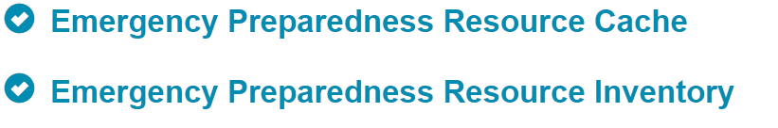
Step 1. Select Emergency Preparedness Resource Cache
These are the functions that Coalition Members can access
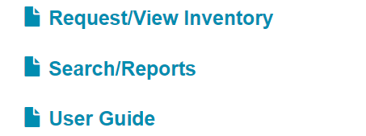
Step 2. Select Request/View Inventory
You should be able to view a list of items for your Region.
This is where you can make a request. In order to request an item, you must click in the Quantity Requesting field, and enter the number of that item being requested. (Please see Criteria for Approval for maximum quantities below)
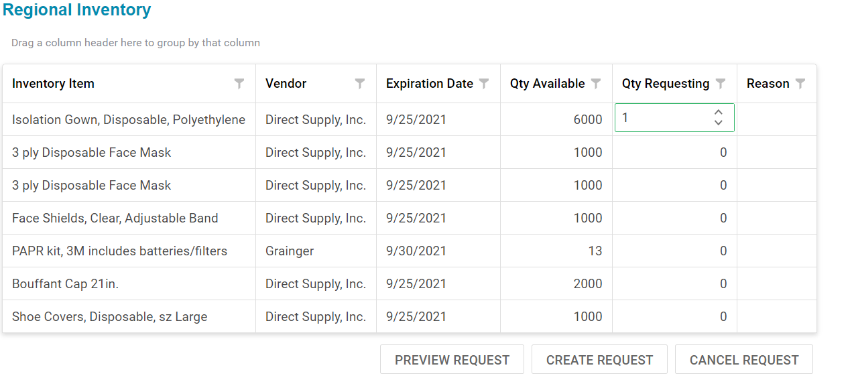
You must also indicate the reason; Surge, Unable to Obtain, or Critical Need
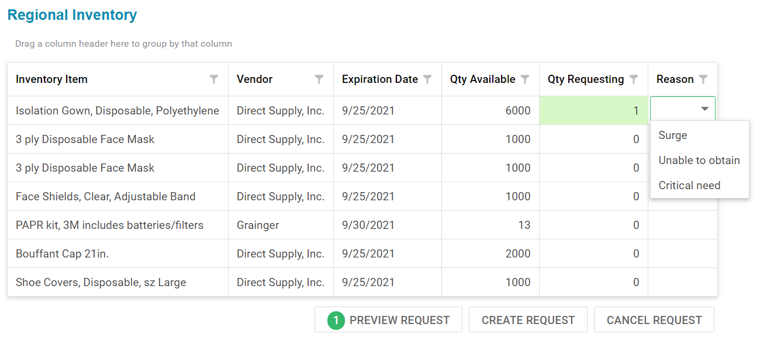
If everything is correct, Click Submit Request
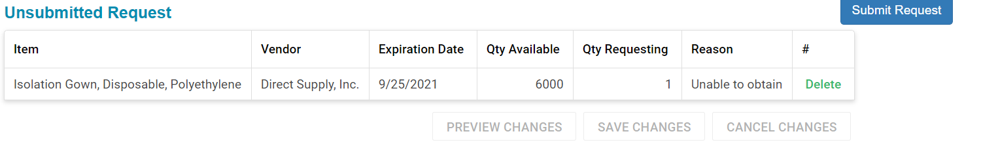

Your Regional Coordinator will see this:
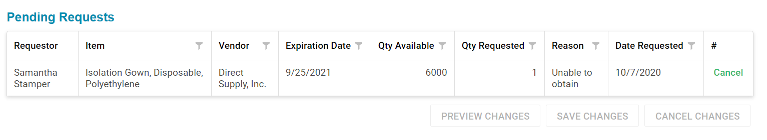Your Regional Coordinator Approves or Declines the Request and will follow up with you on the reason or pick up process. (See Guidelines for Regional Cache Approval below)
Transparency
We are making all Cache Items and all Request for items visible for all regions, or statewide. This will allow all users to know what was obtained, what is available, and what has been distributed, through the Health and Human Services ASPR COVID-19 Supplemental Funding received by West Virginiavia the Hospital and Healthcare Preparedness Program.
Submitted Request will look like this- (Example)
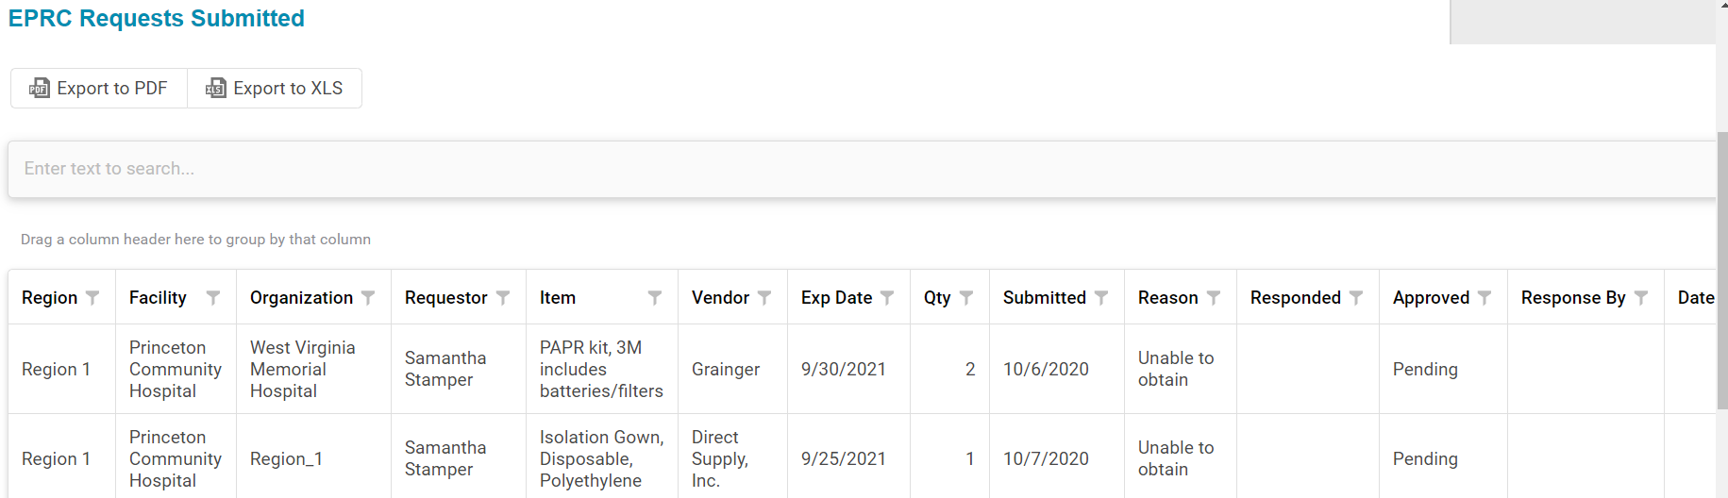

Total Inventory Obtained will look like this:
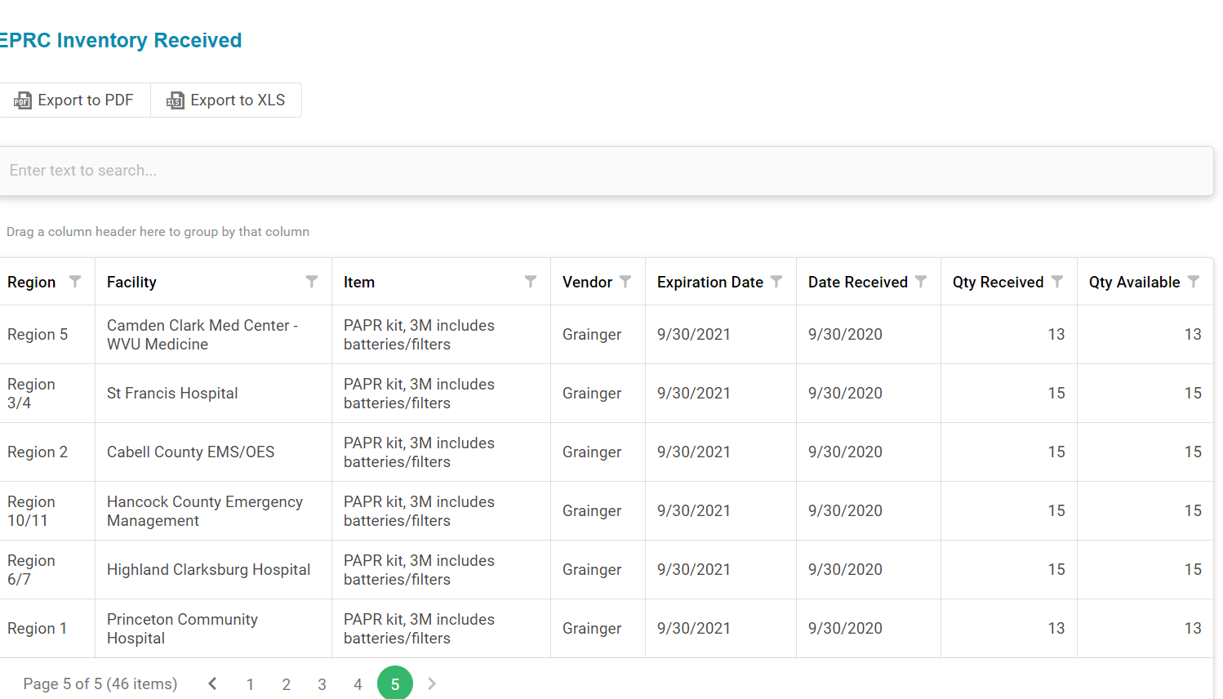

Guidelines for Regional Cache Approval
Requester must be an active coalition member. Active in meetings, Data systems, exercises, drills, planning meetings and have a signed MOU on file.
All active members can make a request for cache items with a few limitations. Certain items are in high demand and we want to ensure everyone has an opportunity to receive a fair share. The following are maximum limits per category.
Regional Coordinators and Regional Chairpersons will determine eligibility.
Item Description | Requirement | Maximum Quantity
Disposable Isolation Gowns | Active HCC Member | 200
Face Shields, clear Lens, Adjustable bands | Active HCC Member | 100
Bouffant Caps in White | Active HCC Member | 500
3 ply disposable face masks with ear loops | Active HCC Member | 500
Disposable Shoe Covers, white | Active HCC Member | 200
PAPR System Kit, includes batteries and filter | Active HCC Member and must be treating a COVID positive patient to request. 1 PAPR kit per 5 positive patients. | 2

